**Testing Notes**

**Login Page:**

**Case 1: Invalid Username/Password**

To test the login page, a different username from the required username (“admin”/ “user”) was inputted. The result of this case was that another frame opened that informed the user that there is an error by displaying the message “Incorrect Username/Password! Please try again”. The frame also included an “okay” button that allowed the user to go back to the login page and try again. The same procedure followed for when a different password was inputted in the program. The login page was also able to handle different data types and displayed the same error message without crashing. [Bilal]

**Case 2: Checking the buttons**

The buttons on the login page was also checked for errors. Each button led to the desired location. The button “Login” worked when the correct username and password was inputted. It led it to the title page of the program and removed the login page. The buttons did not work with blank text field or incorrect password/username. The button “Exit” let the user quit the program. The button works with blank text fields. [Sara]

**Title Page:**

**Case 1: Checking the buttons**

The buttons on the title page was checked for errors. The “View Library” button led to the main page of the program without any errors. The “Help” button led to the help page of the program without any errors. The “Exit” button allowed the user to quit the program without any issues. [Herman]

**Help Page:**

**Case 1: Checking the buttons**

From the title page, when the button “Help” was clicked on, another frame opened. This frame contained instructions to using the program. The only button in this frame was a button called “Main Menu”. Clicking on the button led the user to the title page while closing the help page. There were no issues with the help page. [Herman]

**View Library Page:**

**Case 1: Adding a book**

One of the features of the program is to allow the admin to add a book. When the button “Add a Book” is clicked on, a separate frame opens. This frame includes

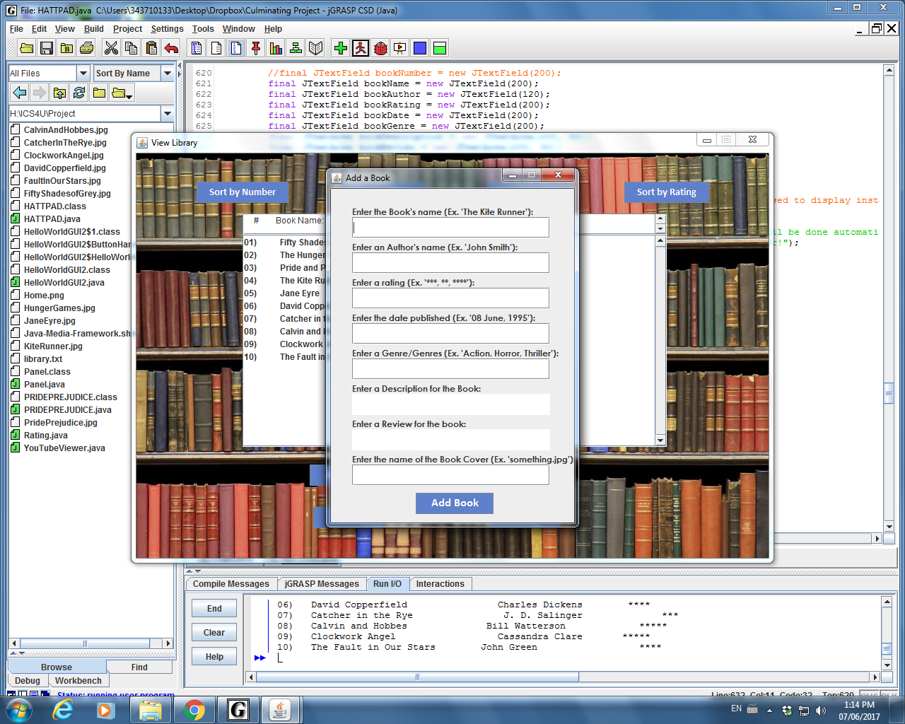

When the following text fields “Enter the Book’s name”, “Enter an Author’s name” and “Enter a rating” in left blank and “Add Book” is clicked on, the frame does not change. It remains that way until the first three fields are filled out. For any other fields that are left blank, the program allows the admin to successfully add the book and displays the information on the library frame. When the user/admin clicks on the newly added book, the book information page only displays the information provided. The newly added book cannot be edited once it’s been added to the program. [Nanziba]

**Case 2: Deleting a Book**

One of the features of the program is that it allows the user to delete books. In order to do so, the admin must select the button “Delete a Book”. Doing so will open another frame that says;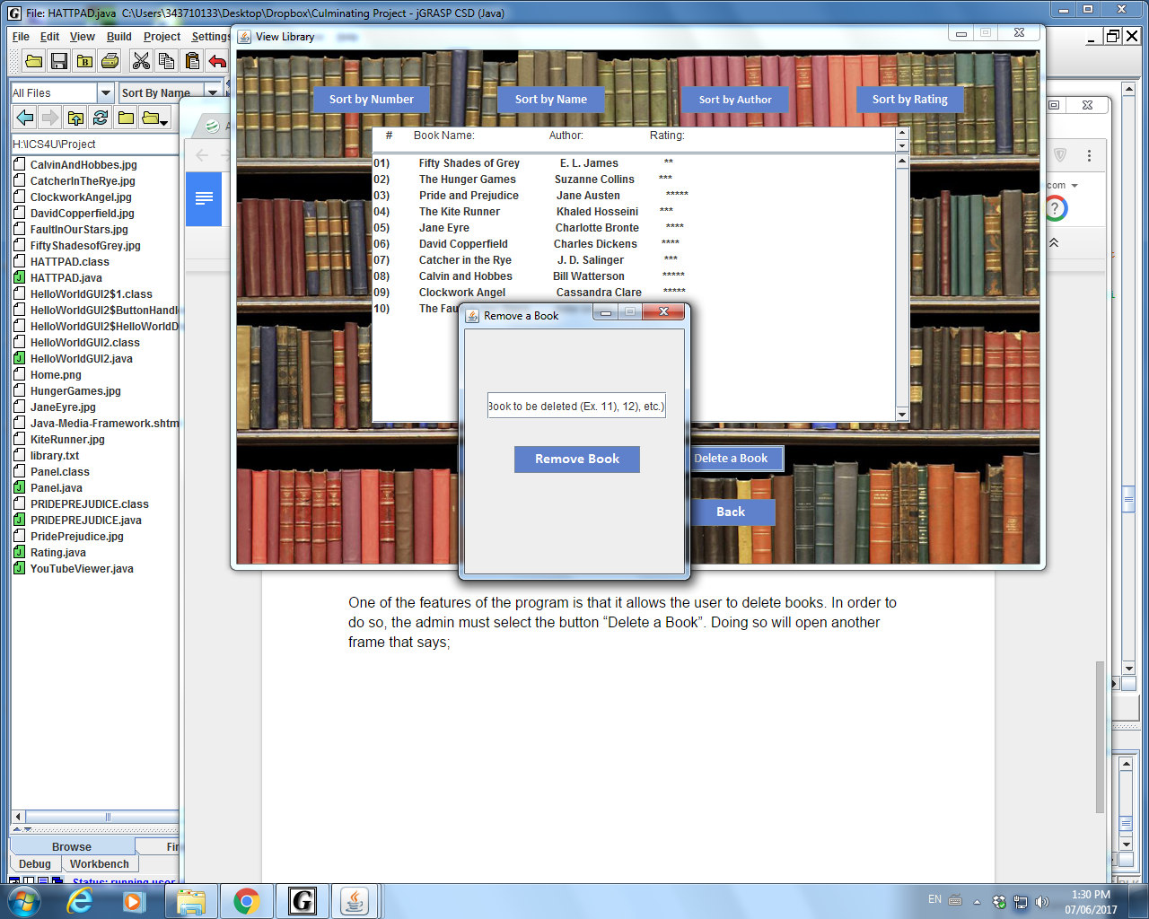

Entering a book’s number that actually exists in the library, will delete the following book by closing the program. The admin must restart the program to see the recent changes. However entering a number that does exist would lead the program to close and when the program is restarted, no changes would appear in the library. The same procedure follows when different data types are inputted into the text field. [Sara]

**Case 3: Sorting Feature**

The program sorts the data successfully according to each category. When the user/admin selects “Sort by Number”, the program sorts all of the books according to their book number and displays the library accordingly. When they select “Sort by Name”, the program sorts all of the books according to their title and displays the library accordingly. When the user/admin selects “Sort by Author”, the program sorts all of the books according to their author’s first name and displays the library accordingly. When the user/admin selects “Sort by Rating”, the program sorts all of the books according to their rating and displays the library accordingly. [Herman]

**Case 4: Checking the buttons**

All the buttons in this frame leads the user to their desired location in the program. The button “Exit” allows the user to quit the program at any point in time. The button “Back” takes the user to the title page by opening a new frame and removing the current frame.

[Bilal]

**Case 5: Using the main page as an user**

Using the main page as a user, removes the buttons “Add a Book” and “Delete a Book”. The user is only allowed to sort books, select a specific book, quit the program and go back to the title page. They are able to use all the features described above successfully. [Nanziba]

**Case 6: Selecting a book**

Selecting a book in the list leads the user to the book information page without any errors. [Sara]

**Book Information Page:**

**Case 1: Editing the Textfield**

The description and the review section of the book information page are located in a textfield. Neither the admin nor the user canedit the textfield. The Scrolling feature works for both textfields. [Bilal]

**Case 2: Checking the buttons**

There is only one button named “Back” on this frame. Clicking on this button leads it to the previous page, which is the main page of the program. [Nanziba]